HOLY EUCHARIST, RITE II

FOURTH SUNDAY AFTER THE EPIPHANY

FEBRUARY 3, 2019

WELCOME
Welcome to ‘Old Durham’ Church. However you got here, whatever your background, you are welcome here for worship, service, and fellowship in the name of our Lord, Jesus Christ. The church is part of the Episcopal Diocese of Washington, and has been feeding souls on this site for over 350 years. It is our prayer that you will encounter God’s love, peace, and hope here.
As Christians in the Anglican tradition, our worship is rooted in Holy Scripture and in the Book of Common Prayer, which for centuries has united Christians all over the world in a common, ever-evolving, format of prayer and worship. You, the members of the congregation, play an important role in our worship; please follow along in this leaflet and speak your parts with confidence. The hymns we sing this morning will be found in this leaflet or in the blue hymnal in the pews.
We worship every Sunday morning at 10:30 AM. There is an an adult Christian formation class most Sunday mornings at 9:15 AM in the Parish Hall, and we are up to all sorts of other things during the week.
Our historic church building has no running water. Restrooms are located in the Parish Hall, across the parking lot from the church.

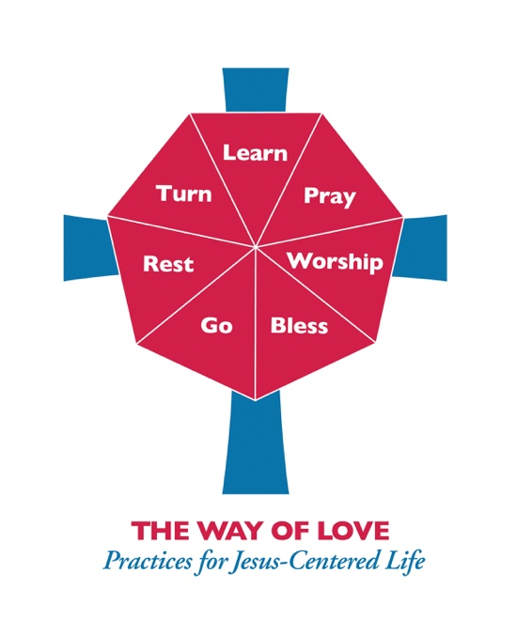
The Way of Love
Our readings and collect for this morning are drawn from an eight-week lectionary compiled for The Way of Love, the Presiding Bishop's initiative for strengthening and enricing the spiritual life of the Episcopal Church.

ANNOUNCEMENTS
Prelude
Entrance Rite

Entrance Hymn Christ, whose glory fills the skies (Ratisbon) (Hymnal 7)

Opening Acclamation
Presider | Blessed be the one, holy, and living God.
People | Glory to God for ever and ever.

Collect for Purity

Glory to God Ev'ry Time I Feel the Spirit (LEVAS 114)
Collect of the Day
O God, whose glory it is always to have mercy: Be gracious to all who have gone astray from your ways, and bring them again with penitent hearts and steadfast faith to embrace and hold fast the unchangeable truth of your Word, Jesus Christ your Son; who with you and the Holy Spirit lives and reigns, one God, for ever and ever. Amen.

The Lessons

First Reading: Exodus 3:1-6
A Reading from the book of Exodus.
¹Moses was keeping the flock of his father-in-law Jethro, the priest of Midian; he led his flock beyond the wilderness, and came to Horeb, the mountain of God. ²There the angel of the LORD appeared to him in a flame of fire out of a bush; he looked, and the bush was blazing, yet it was not consumed. ³Then Moses said, “I must turn aside and look at this great sight, and see why the bush is not burned up.” ⁴When the LORD saw that he had turned aside to see, God called to him out of the bush, “Moses, Moses!” And he said, “Here I am.” ⁵Then he said, “Come no closer! Remove the sandals from your feet, for the place on which you are standing is holy ground.” ⁶He said further, “I am the God of your father, the God of Abraham, the God of Isaac, and the God of Jacob.” And Moses hid his face, for he was afraid to look at God.

Reader | The Word of the Lord.
People | Thanks be to God.

Psalm: Psalm 119:169-176
Remain seated.
¹⁶⁹Let my cry come before you, O LORD;
give me understanding according to your word.
¹⁷⁰Let my supplication come before you;
deliver me according to your promise.
¹⁷¹My lips will pour forth praise,
because you teach me your statutes.
¹⁷²My tongue will sing of your promise,
for all your commandments are right.
¹⁷³Let your hand be ready to help me,
for I have chosen your precepts.
¹⁷⁴I long for your salvation, O LORD,
and your law is my de-light.
¹⁷⁵Let me live that I may praise you,
and let your ordinances help me.
¹⁷⁶I have gone astray like a lost sheep; seek out your servant,
for I do not forget your com-mandments.

Second Reading: 2 Corinthians 4:5-7
A Reading from Paul’s Second letter to the Church in Corinth.
⁵For we do not proclaim ourselves; we proclaim Jesus Christ as Lord and ourselves as your slaves for Jesus' sake. ⁶For it is the God who said, "Let light shine out of darkness," who has shone in our hearts to give the light of the knowledge of the glory of God in the face of Jesus Christ.
⁷But we have this treasure in clay jars, so that it may be made clear that this extraordinary power belongs to God and does not come from us.

Reader | The Word of the Lord.
People | Thanks be to God.

Sequence Hymn When Israel was in Egypt's land (Go Down, Moses) (Hymnal 648)

Gospel: Luke 5:1-11
Deacon | The Holy Gospel of our Lord Jesus Christ according to Luke.
People | Glory to you, Lord Christ.

¹Once while Jesus was standing beside the lake of Gennesaret, and the crowd was pressing in on him to hear the word of God, ²he saw two boats there at the shore of the lake; the fishermen had gone out of them and were washing their nets. ³He got into one of the boats, the one belonging to Simon, and asked him to put out a little way from the shore. Then he sat down and taught the crowds from the boat. ⁴When he had finished speaking, he said to Simon, "Put out into the deep water and let down your nets for a catch." ⁵Simon answered, "Master, we have worked all night long but have caught nothing. Yet if you say so, I will let down the nets." ⁶When they had done this, they caught so many fish that their nets were beginning to break. ⁷So they signaled their partners in the other boat to come and help them. And they came and filled both boats, so that they began to sink. ⁸But when Simon Peter saw it, he fell down at Jesus' knees, saying, "Go away from me, Lord, for I am a sinful man!" ⁹For he and all who were with him were amazed at the catch of fish that they had taken; ¹⁰and so also were James and John, sons of Zebedee, who were partners with Simon. Then Jesus said to Simon, "Do not be afraid; from now on you will be catching people." ¹¹When they had brought their boats to shore, they left everything and followed him.

Deacon | The Gospel of the Lord.
People | Praise to you, Lord Christ.

The Sermon

The Nicene Creed
We believe in one God, the Father, the Almighty, maker of heaven and earth, of all that is, seen and unseen.
We believe in one Lord, Jesus Christ, the only Son of God, eternally begotten of the Father, God from God, Light from Light, true God from true God, begotten, not made, of one Being with the Father. Through him all things were made. For us and for our salvation he came down from heaven: by the power of the Holy Spirit he became incarnate from the Virgin Mary, and was made man. For our sake he was crucified under Pontius Pilate; he suffered death and was buried. On the third day he rose again in accordance with the Scriptures; he ascended into heaven and is seated at the right hand of the Father. He will come again in glory to judge the living and the dead, and his kingdom will have no end.
We believe in the Holy Spirit, the Lord, the giver of life, who proceeds from the Father and the Son. With the Father and the Son he is worshiped and glorified. He has spoken through the Prophets. We believe in one holy catholic and apostolic Church. We acknowledge one baptism for the forgiveness of sins. We look for the resurrection of the dead, and the life of the world to come. Amen.

The Prayers of the People .
In peace, let us pray to the Lord, saying, “Lord, have mercy.”
For the holy Church of God, that it may be filled with truth and love, and be found without fault at the day of your coming, we pray to you, O Lord. Lord, have mercy.
For Michael our Presiding Bishop, for Mariann our own Bishop, for all bishops and other ministers, and for all the holy people of God, we pray to you, O Lord. Lord, have mercy.
For all who fear God and believe in you, Lord Christ, that our divisions may cease, and that all may be one as you and the Father are one, we pray to you, O Lord. Lord, have mercy.
For the peace of the world, that a spirit of respect and forbearance may grow among nations and peoples, we pray to you, O Lord. Lord, have mercy.
For those in positions of public trust, that they may serve justice, and promote the dignity and freedom of every person, we pray to you, O Lord. Lord, have mercy.
For the poor, the persecuted, the sick, and all who suffer; for refugees, prisoners, and all who are in danger; that they may be relieved and protected, we pray to you, O Lord. Lord, have mercy.
For this congregation, that we may be delivered from hardness of heart, and show forth your glory in all that we do, we pray to you, O Lord. Lord, have mercy.
For all who have commended themselves to our prayers; for our families, friends, and neighbors; that being freed from anxiety, they may live in joy, peace, and health, we pray to you, O Lord. Lord, have mercy.
For those joys and concerns that we now name aloud or in the silence of our hearts; (Silence. The congregation may add their petitions.) We pray to you, O Lord. Lord, have mercy.
For all who have died in the communion of your Church, and those whose faith is known to you alone, that, with all the saints, they may have rest in that place where there is no pain or grief, but life eternal, we pray to you, O Lord. Lord, have mercy.
Rejoicing in the fellowship of the ever-blessed Virgin Mary and all the saints, let us commend ourselves, and one another, and all our life to Christ our God. To you, O Lord our God.
Silence
The Presider adds a concluding Collect, or the following Doxology
For yours is the majesty, O Father, Son, and Holy Spirit; yours is the kingdom and the power and the glory, now and for ever. Amen.

Confession of Sin
PENITENTIAL SENTENCE
A period of silence is kept. Kneeling as they are able, all say together
Most merciful God, we confess that we have sinned against you in thought, word, and deed,
by what we have done, and by what we have left undone. We have not loved you with our whole heart; we have not loved our neighbors as ourselves. We are truly sorry and we humbly repent. For the sake of your Son Jesus Christ, have mercy on us and forgive us; that we may delight in your will, and walk in your ways, to the glory of your Name. Amen.
THE ABSOLUTION
The Peace
All stand.
Presider | The peace of Christ be always with you.
People | And also with you.

The Ministers and the People may greet one another in the name of Christ.
BLESSING OF PRAYER SHAWLS
Leader | Without even knowing who would receive it, this shawl was made specifically for the person who will receive it.
People | May they see the intricate love and care given to this shawl, mirroring the intricate love and care that God bestows upon all people.
Leader | This shawl was made to bring warmth to someone who feels a chill.
People | May they feel the warm breath of the Holy Spirit as they wrap themselves with it.
Leader | This shawl was made to bring comfort to someone who feels alone.
People | May they feel comfort in knowing that someone prayed for them as they pieced it together.
Leader | This shawl was made to bring peace to someone in need of prayer.
People | May they feel the power of our prayers as they feel the yarn winding through their fingers.
Leader | This shawl was made to remind the recipient that they are part of this community.
People | May they feel touched by our love, moved by our guidance, and held up by our support.
Presider | God of creation, redemption, and sustaining grace, we praise you for the opportunity to take part in this ministry so that we might see a world beyond our own. We thank you for putting those in need on our hearts and in our minds so that we might more fully love out your call to love and serve. ✢ Bless these shawls and those who will receive them. May they feel the love, comfort, and peace of your presence. And may your light shine in them and be a beacon of the hope that is promised to all of us.
All | Amen.
The Holy Communion
Seeing how greatly God loves us, we share freely of the good things we have received. Place your gifts of money for the poor and for the work of the church in the offering plates as the ushers bring them around. These gifts of money, along with symbolic gifts of bread and wine, will be brought to the altar to be blessed and shared in the body and blood of Christ. If this is your first time here, we'd like you to be our guest, as well as Jesus' guest. Instead of making an offering, spend this week noticing all the ways that God blesses you. Then, next time you come back, give generously in thanksgiving for all that you have been given.
Holy Communion is the body and blood of our Lord Jesus Christ given with bread and wine. All baptized Christians regardless of denomination are welcome to come to the altar rail to share in this meal of life. If you prefer not to receive Communion, you may come forward and cross your arms over your chest, and the priest will offer a prayer of blessing.
We offer both wine and grape juice at Communion. The first (larger) cup has wine and the second (smaller) cup has grape juice. You may drink or intinct from either.
The bread will be placed in your hand. You may either, (1) Eat the bread and drink from the cup which follows; or (2) Hold the bread, dipping it in the cup and then eating the bread. If you do not wish to receive wine, please cross your arms after receiving the bread.
If you prefer to receive Communion at your seat in the pew, we will be happy to bring it to you.

Offertory Hymn Dear Lord and Father of mankind (Rest) (Hymnal 652)

The Great Thanksgiving

Sursum Corda
Presider | The Lord be with you.
People | And also with you.
Presider | Lift up your hearts.
People | We lift them to the Lord.
Presider | Let us give thanks to the Lord our God.
People | It is right to give God thanks and praise.

It is right, and a good and joyful thing, always and everywhere to give thanks to you, Almighty God, Creator of heaven and earth. Because in the mystery of the Word made flesh, you have caused a new light to shine in our hearts, to give the knowledge of your glory in the face of your son Jesus Christ our Lord.
Therefore we praise you, joining our voices with Angels and Archangels and with all the company of heaven, who for ever sing this hymn to proclaim the glory of your Name:

SAnctus
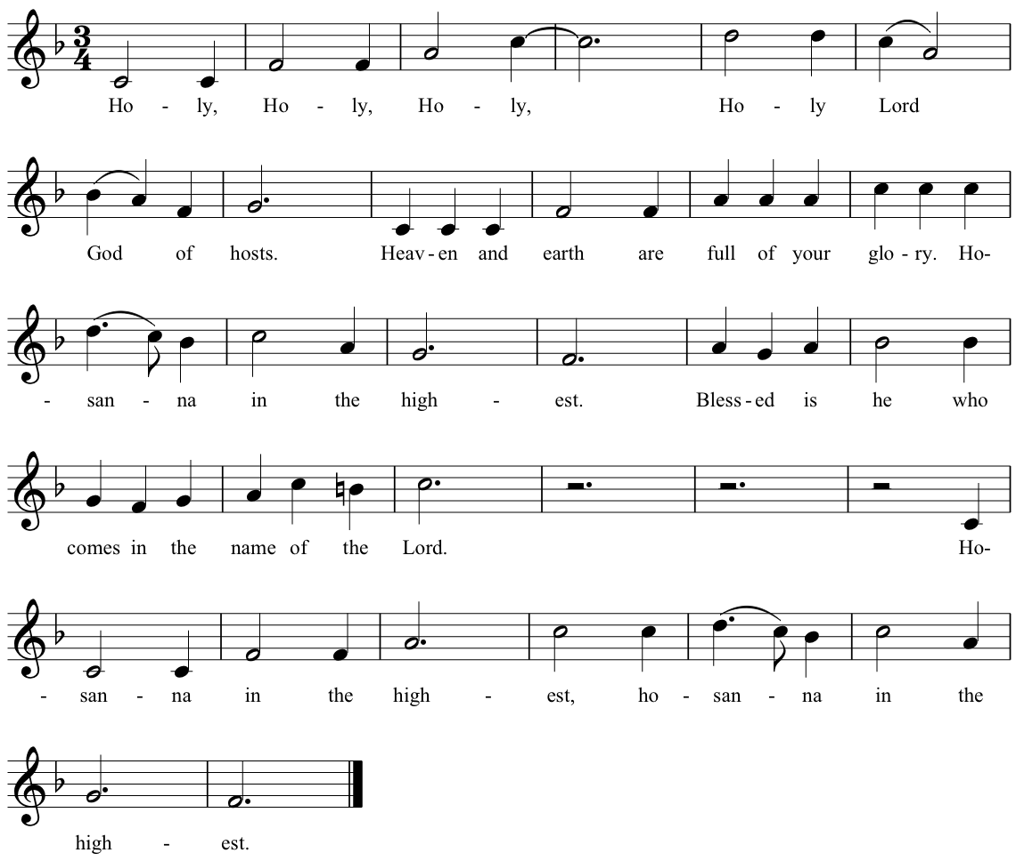

We give thanks to you, O God, for the goodness and love which you have made known to us in creation; in the calling of Israel to be your people; in your Word spoken through the prophets; and above all in the Word made flesh, Jesus, your Son. For in these last days you sent him to be incarnate from the Virgin Mary, to be the Savior and Redeemer of the world. In Christ, you have delivered us from evil, and made us worthy to stand before you. In Christ, you have brought us out of error into truth, out of sin into righteousness, out of death into life.
On the night before he died for us, our Savior Jesus Christ took bread; and when he had given thanks to you, he broke it, and gave it to his disciples, and said, “Take, eat: This is my Body, which is given for you. Do this for the remembrance of me.”
After supper Jesus took the cup of wine; and when he had given thanks, he gave it to them, and said, “Drink this, all of you: This is my Blood of the new Covenant, which is shed for you and for many for the forgiveness of sins. Whenever you drink it, do this for the remembrance of me.” Therefore, according to his command, O Father,
We remember his death,
We proclaim his resurrection,
We await his coming in glory;
And we offer our sacrifice of praise and thanksgiving to you, O Savior of all; presenting to you, from your creation, this bread and this wine.
We pray you, gracious God, to send your Holy Spirit upon these gifts that they may be the Sacrament of the Body of Christ and his Blood of the new Covenant. Unite us in the sacrifice of Jesus Christ, through whom we are acceptable to you, being sanctified by the Holy Spirit. In the fullness of time, put all things in subjection under your Christ, and bring us to that heavenly country where, with all your saints, we may enter the everlasting heritage of your sons and daughters; through Jesus Christ our Savior, the firstborn of all creation, the head of the Church, and the author of our salvation.
By Christ, and with Christ, and in Christ, in the unity of the Holy Spirit all honor and glory is yours, Almighty Father, now and for ever.

(S 146)

The Lord’s Prayer
Our Father, who art in heaven, hallowed be thy Name, thy kingdom come, thy will be done, on earth as it is in heaven. Give us this day our daily bread. And forgive us our trespasses, as we forgive those who trespass against us. And lead us not into temptation, but deliver us from evil. For thine is the kingdom, and the power, and the glory, forever and ever. Amen.

The Breaking Of The Bread

Fraction Anthem
Alleluia. Christ our Passover is sacrificed for us;
Therefore let us keep the feast. Alleluia.
Invitation
Behold what you are; may you become what you receive.
The choir and the congregation come forward to receive Communion.
Post-Communion Prayer
Eternal God, you have graciously accepted us as living members of our Savior Jesus Christ, and you have fed us with spiritual food in the Sacrament of his Body and Blood. Send us now into the world in peace, and grant us strength and courage to love and serve you with gladness and singleness of heart; through Christ our Savior. Amen.

Blessing

Closing Hymn Praise to the living God (Leoni) (Hymnal 372)

Dismissal
Deacon | Let us go forth in the name of Christ.
People | Thanks be to God.

POSTLUDE
PRAYER LIST
Let us pray...
...in thanksgiving for the members of our congregation: Mary Mosher, Rick Posey, David Rohde, and Matthew Rohde.
...for those who travel or are absent for a time: June and Gary Leyland; Cindy Shoemaker.
...for support and protection for those who serve our country at home and abroad: Mike Busey, Christopher Walker, Steven Mattingly, Sam Gray, Wes Dyson, Michael Petrusic, and Thomas J. Huntt.
...for those in need of God’s healing grace: Missy Bowie; Chris Bowie; Lindy Lynch; Erin Macri; John Matthewson; Bonnie Santora; Our continuing prayers are offered for: Hope Cameron; Conor Doyle; George Dyson; Butch Helwig; Carol Hindle; Dian Lockamy; Buddy Linton; Sam Linton; Rhonda McGraw; Jeanne Read; Jean Santora; Rose Speake; Joan Shoemaker; Roy Squires; The Rev. Arnold Taylor; Lisa Tuono; Luci Wright.
The Diocese of Washington cycle of prayer: St. Timothy's Parish, DC; St. Timothy's Child Development Center, DC; Episcopal Relief and Development; Theological Education Sunday. The Anglican Communion cycle of prayer: The Anglican Church of Burundi: The Most Revd Martin Blaise Nyaboho - Archbishop of Burundi & Bishop of Makamba.

ANNOUNCEMENTS
Don’t forget that these announcements can also be found on the church website, OldDurham.org. You can view them in the calendar (look under “About Us” in the upper left) or view the service bulletin via the ‘Bulletin Announcements” button. When you read them on line, you can follow the links to websites mentioned in the announcements.
Adult Forum: Please join us at 9:15am in the Parish Hall on Sunday mornings for coffee, learning, and thought-provoking discussion.
Coffee After Church: Join us after church in the Parish Hall for a cup of coffee and conversation.
Worship Committee will meet today after church in the Parish Hall.
Annual Absalom Jones Service: Today, 3pm at St. Andrew's Episcopal Church, 4512 College Avenue, College Park MD. Celebrant: The Rt. Rev. Mariann Budde; Preacher: The Rev. Mark Jefferson, Virginia Theological Seminary. According to the invitation: “Yes, it’s SuperBowl Sunday and we will have you home in plenty of time.”
Daughters of the King and Mens Group will meet on Monday, Feb. 4 at 6:30pm in the Parish Hall.
Pastoral Care Team will meet Feb. 10 after church in the Parish Hall.
Ladies Mites Society will meet on Tues., Feb. 12 at 1:30pm in the Parish Hall.
Joe’s Place Food Pantry distributions are on the second and fourth Thursdays of the month from 4:30 to 6pm in the Parish Hall. The next distributions are Feb. 14 and 28. Volunteers are always welcome to sort and distribute food to our neighbors. Contact: John Welch.
Coffee Hour: The Daughters of the King will host a Coffee Hour after church on February 17.
Health and Wellness Ministry Discernment Group will meet Tues., Feb. 19 at 11am in the Parish Hall.
Special Parish Meeting: On March 3 after church we will hold a special Parish Meeting to elect two new members to the Vestry. Millie Hamman and Bill White are concluding their years of Vestry service, and in to bring us into compliance with our new by-laws (approved by the parish last November) we will be electing two new Vestry members in March 2019, November 2019, and March 2020. A list of parish members entitled to vote in next month’s election is posted in the Parish Hall and is available from the Vestry Secretary. If you have any questions about the list, please contact Rev. Catharine or Senior Warden Rick Posey.

OF NOTE IN THE WIDER CHURCH
Absalom Jones Offering
In honor of Black History Month and Blessed Absalom Jones, the first African American priest in the Episcopal Church, Presiding Bishop Michael Curry has invited Episcopalians everywhere to deepen our participation in Christ’s ministry of reconciliation by engaging with and supporting Episcopal Historically Black Colleges and Universities, known as HBCUs.
Congregations and individuals are urged to dedicate the offering from their observance of the Feast of Absalom Jones (February 13) to support the two Episcopal HBCUs: St. Augustine’s University in Raleigh, N.C., and Voorhees College in Denmark, S.C. “These schools bring educational, economic, and social opportunity to often resource-poor communities, and they offer many blessings into the life of the Episcopal Church,” Bishop Curry said. Donations to the HBCUs will provide much-needed help to offer competitive scholarships and financial aid, attract and retain exceptional faculty, support cutting-edge faculty research, install new and upgraded technology campus-wide, and provide state-of-the-art classroom and athletic equipment.
“The Episcopal Church established and made a life-long covenant with these schools, and they are an essential part of the fabric of our shared life,” the Presiding Bishop noted.
Jones was an African-American abolitionist and clergyman and the first African American ordained a priest in The Episcopal Church. He was born enslaved to Abraham Wynkoop in 1746 in Delaware. Jones moved to Philadelphia after his master sold his plantation along with Absalom’s mother and six siblings. Jones bought his wife Mary’s freedom and later his master granted Absalom’s emancipation in 1784. In 1787, with his friend Richard Allen, they founded the Free African Society, a mutual aid benevolent organization that was the first of its kind organized by and for black people. Jones was ordained a priest on September 21, 1802, faithfully serving the African Episcopal Church of St. Thomas in Philadelphia, a church which remains a vibrant congregation.
“As we approach February, the remembrance of the Blessed Absalom Jones, the first African-American priest in the Episcopal Church, we have a unique opportunity to celebrate his memory and to honor the witness of two schools that continue to form new leaders,” Bishop Curry said. “In honor of Jones’ commitment to advancing the education of African Americans and promoting the development of African American leaders in all areas of life, the Episcopal Church is delighted to designate Saint Augustine’s University and Voorhees College as the beneficiaries of the 2019 Feast of Absalom Jones offerings.”
Donations are accepted at episcopalchurch.org/give. For more information, contact Cecilia Malm, Development Officer, at cmalm@episcopalchurch.org or (212) 716-6062.

MINISTERS IN TODAY’S SERVICE
Readers: Roy Squires and Patrice Rohde; Preacher and Presider: The Rev. Catharine T. Gibson; Intercessor: George Chisholm; Chalicists: Barbara Macri and Linda Buffalo; Altar Guild: Dian Lockamy.

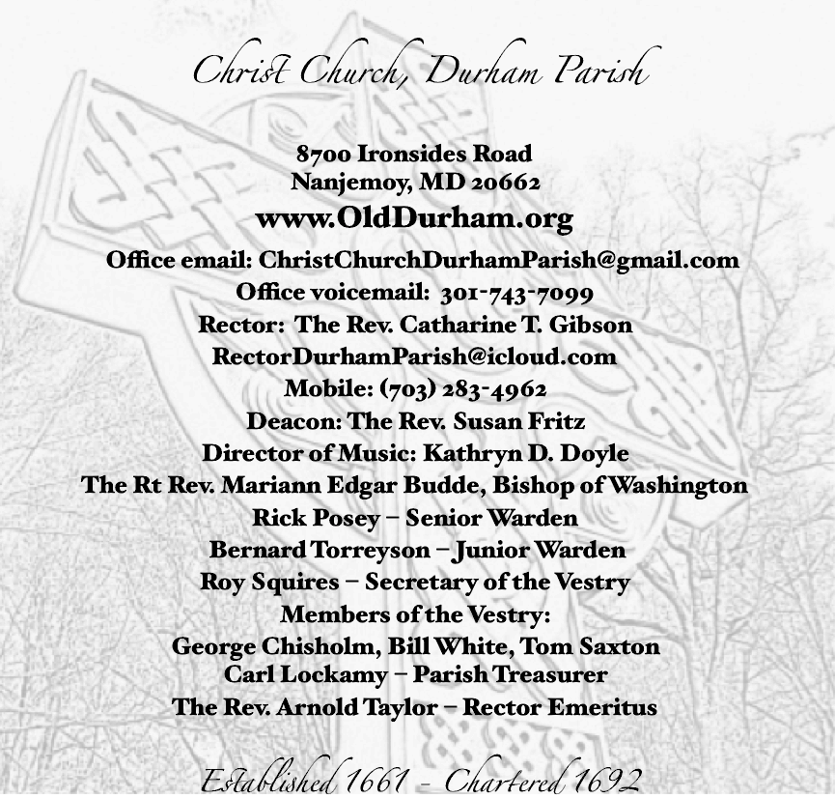

From riteplanning.com. Copyright © 2019 Church Publishing Inc. All rights reserved.

