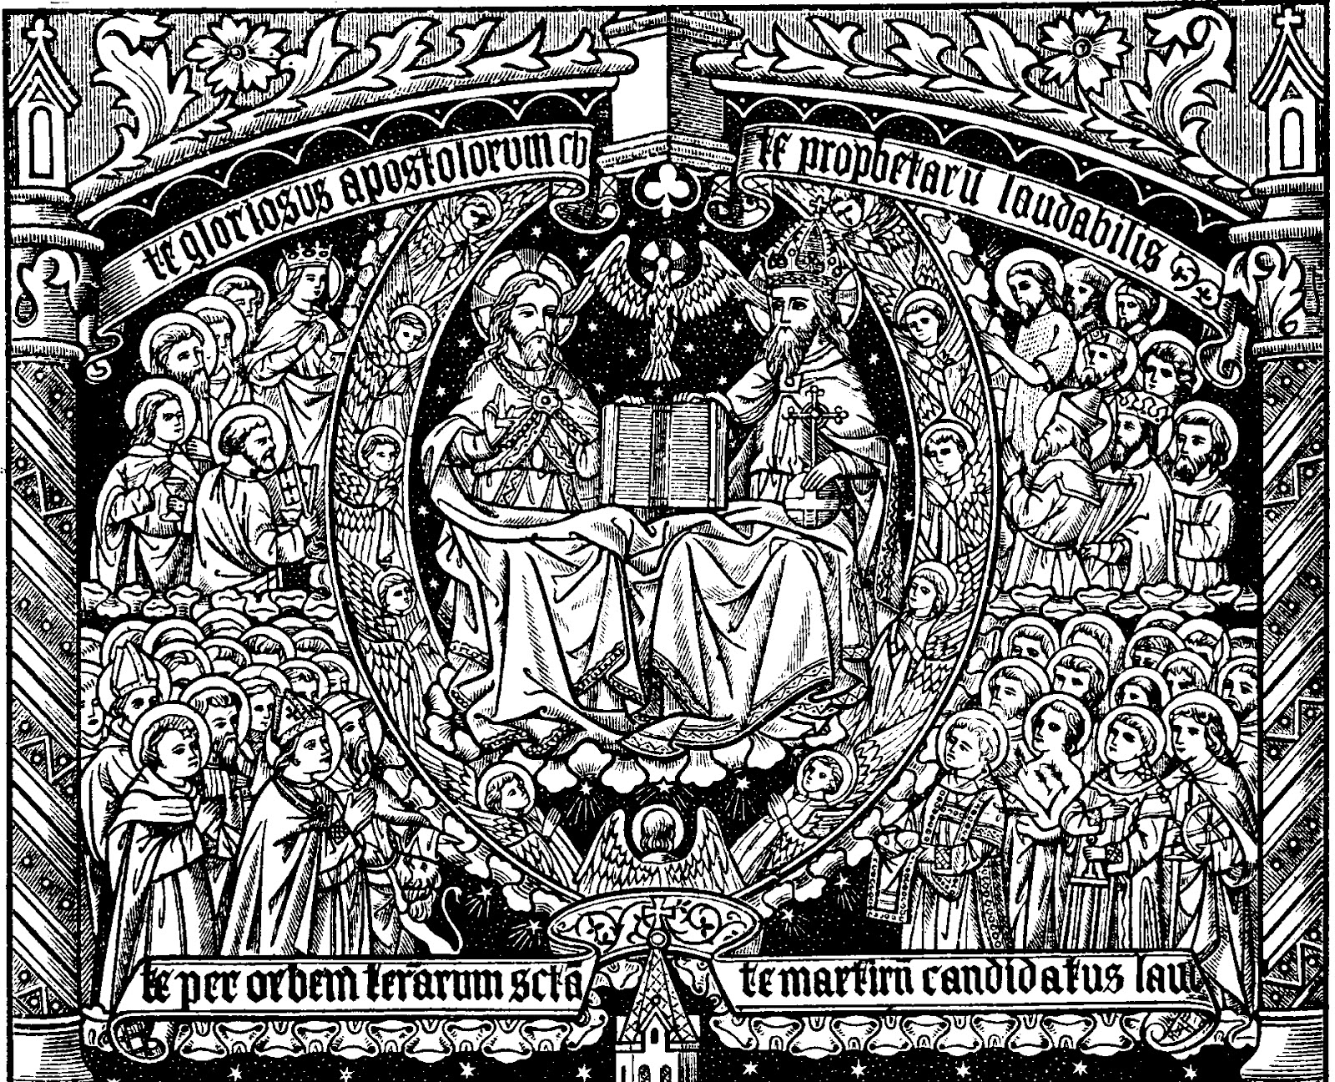

ALL SAINTS’ SUNDAY
COMMEMORATION OF THOSE WHO HAVE DIED

The following are among the and friends of this church who have died in the past year. They are remembered by name in our eucharistic prayer today.

Hilda Cameron (buried December 2018)
Arnold Taylor
Missy Bowie
Marlyne Weakley (buried May 2019)
George Dyson
Jane Fritz (mother-in-law of Deacon Susan)
Lindy Lynch (best friend of Deacon Susan)
Kim Trice (co-worker of Deacon Susan)
Gaynelle Hoover (mother of Carl Lockamy)
Dorothy Knight (aunt of Carl Lockamy)
Ethel Lockamy (aunt of Carl Lockamy)
Dorothy Barbour (friend of the church)
Frank Vandevelder (friend of Rev. Catharine).

PRAYER LIST
Let us pray...
...in thanksgiving for the members of our congregation: Chuck Busey, George Chisholm, Phyllis Chisholm, and Mary Lou Clem.
...for support and protection for those who serve our country at home and abroad: Alex Berger (husband of Patrice Rohde’s niece), Mike Busey (son of Chris and Chuck Busey), Wes Dyson (grandson of George and Ruby Dyson), and Thomas J. Huntt (nephew of Sue Huntt); Steven Mattingly (friend of the Chisholms).
...for those in need of God’s healing grace: Vivian Aldridge (mother of Barbara Macri), Wayne Buffalo, Mary Lou Clem, Carl Fletcher (friend of Chris Dudley), Butch Helwig (Nanjemoy resident), Livvy Huisman (mother of Kathy Doyle), Rick Posey, Tom Saxton, Cindy Shoemaker, John Warner (brother-in-law of Kathy Doyle); Our continuing prayers are offered for: Mabel Bowie, Sam Gray, Buddy Linton, Rhonda McGraw (daughter of John and Patsy Welch), Jeanne Read, Jean Santora, Rose Speake (friend of Gloria Hampton), Joan Shoemaker (wife of Deacon Eric Shoemaker), Roy Squires, and Luci Wright (aunt of Barbara Macri).
…for those who have died: George Dyson.
The Diocese of Washington cycle of prayer: Presiding Bishop Michael Curry; All Saints’ Church, Chevy Chase; All Saints’ Pre-School, Chevy Chase; All Saints’ Parish, Oakley. The Anglican Communion cycle of prayer: Pray for the Church of Bermuda (Extra-Provincial to the Archbishop of Canterbury) The Rt Revd Nicholas Dill – Bishop of Bermuda.

ANNOUNCEMENTS
Don’t forget that these announcements can also be found on the church website, OldDurham.org. You can view them in the calendar (look under “About Us” in the upper left) or view the service bulletin via the ‘Bulletin Announcements’ button.
Adult Forum: Adult Forum will resume on November 10th with a discussion of Chapters 6 and 7 of Falling Upwards: A Spirituality For The Second Half Of Life.
The Alpha Class is drawing to a close. The final session will be November 13. Sign up at this link, or by contacting Deacon Susan or Rev. Catharine: https://www.signupgenius.com/go/20f0949adac2aa7fe3-durham
Daughters of the King and Men’s Group. Nov. 4 at 6:30 pm in the Parish Hall.
Mt Hope/Nanjemoy Thanksgiving Lunch for Seniors. This popular free event is scheduled for Nov. 15th from 12pm to 2pm. Aged 65 and above are welcome. RSVPs are due by Nov. 8th to Dyanna Finamore (dfinamore@ccboe.com) or Ellen Dobry (edobry@ccboe.com) or 301-753-1761.
Healing Service and Pastoral Care Team. We will offer healing prayer with anointing and the laying on of hands at the 10:30 service on November 10. The Pastoral Care Team will meet in the Parish Hall after the service.
Ladies Mite Society. November 12 at 1:30 pm in the Parish Hall.
Joe’s Place Food Pantry distributions are normally on the second and fourth Thursdays of the month from 4:30 to 6pm in the Parish Hall. In November and December they are held on the second and third Thursdays, to accommodate Thanksgiving and Christmas. The next distributions are Nov. 14th and 21st. Volunteers are always welcome to sort and distribute food to our neighbors.
Pledge In-gathering. Our annual pledge campaign is underway; pledge packets were distributed last week. If you have not received yours, or have any questions, please let Rev. Catharine know. Please plan to return your pledge cards in their red envelopes by Nov. 17th. We will bless all the cards, and the intentions they represent, that day at the Offertory.
Worship with us on Thanksgiving Day. We will hold a service of Holy Eucharist at 10AM on Thanksgiving Day. Bring your friends and neighbors!
Parish ‘Community Choir’ on Christmas Eve. Would you be interested in singing as part of a ‘Community Choir’ for our service on Christmas Eve? There’s a move afoot to have a special-occasion Christmas Eve Choir to sing an anthem at the Christmas Eve service. Rehearsals would be on a few Sundays after church. Speak to Kathy if you’d like to know more or be part of this.
The Charles County Literacy Council’s Spelling Bee has been re-scheduled, and now we have plenty of time to organize our team! The event is a fund-raiser for the Literacy Council. It will be held on Saturday, Jan. 11 from 6pm to 10pm at St Mary’s Catholic Church in Bryantown. Tickets are $30, which includes heavy hors d’oeuvres and soft drinks (beer and wine available for sale). Speak to Barbara Macri for details and to volunteer for a team. Scholarships are available, so don’t let cost deter you.

UPDATE ON MT HOPE / NANJEMOY SCHOOL. Deacon Susan attended the Pastors’ Breakfast at Mt Hope/Nanjemoy last week and learned about a number of service opportunities.
Volunteers. The school is happy to have volunteers come in to sit at lunch, read with the children, etc. To volunteer in the schools you must first go to the CCBOE website for training and registration, which includes a background check.
Holiday baskets for local children and families. Once again this year NETS (Neighbors Eager to Serve) will be coordinating the Thanksgiving and Christmas Dinner baskets for school families. We will be providing baskets for six families; NETS has provided boxes and a list of food items for each family. Please sign up in the back to bring food for our neighbors. The deadline is Nov. 25 (for the Thanksgiving baskets) and Dec. 19 (for the Christmas ones). Deacon Susan is looking for help transporting the food to the school on November 25th.
Holiday Stockings. We have 5 children for whom we will provide stocking gifts. We can either collect the items or the money with which to purchase them. The deadline for the stockings is Dec. 6. Dian Lockamy is helping to organize this effort.

MINISTERS IN TODAY’S SERVICE
Presider and Preacher: The Rev. Catharine T. Gibson; Readers: June Leyland and Cindy Shoemaker. Intercessor: Gary Leyland; Chalicists: Carl Lockamy and Mary Lou Clem; Altar Guild: Ruth White. Flower contact for November: Cindy Hampton.
The Sunday morning worship-serving schedule and readings can be viewed or downloaded online. Follow the ‘Bulletin Announcements’ button at the top left of the church website.

Christ Church, Durham Parish
8700 Ironsides Road, Nanjemoy, MD 20662
OldDurham.org
Office email: ChristChurchDurhamParish@gmail.com
Office voicemail: 301-743-7099
Rector: The Rev. Catharine T. Gibson Deacon: The Rev. Susan Fritz
Director of Music: Kathryn D. Doyle
Rector email: RectorDurhamParish@icloud.com Rector mobile phone: (703) 283-4962
Deacon email: Deacon.Susan.Fritz@gmail.com Deacon mobile phone: (301) 643-4233
Vestry: Rick Posey (Senior Warden), Bernie Torreyson (Junior Warden),
George Chisholm, Dian Lockamy, Tom Saxton, Jean Santora, Roy Squires (Secretary);
Parish Treasurer: Carl Lockamy.

From riteplanning.com. Copyright © 2019 Church Publishing Inc. All rights reserved. The eucharistic preface is drawn from LaughingBird.net; the Gloria (Robert Lau) and Sanctus and Fraction (Sally Ann Morris) are copied with permission from St James’ Music Press.

